Figures and Tables for the paper

**Part 1. Tables**

1. **Numbers of annotated miRNAss and theirs classifications in miRbase 21 . (whih MSU did you use for annotation?)**

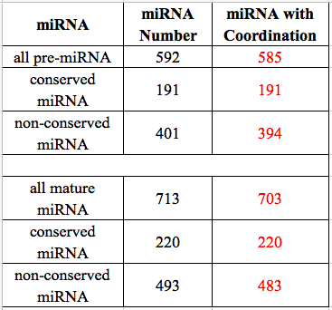

All information for the miRNAs wass from miRBase 21 (http://www.mirbase.org/). SomemiRNAs’ genome coordinations are not provided in the database therefore were obtained by using BLAST.

are provided

(There are 592 rice pre-miRNAs along with 713 mature miRNAs documentedin *miRBase.org* in total, where we obtained the genome coordination of 585 pre-miRNAs and 703 mature miRNAs.

Among xxx miRNAs, 191 fall into the category of conserved miRNAs, all of which have coordination information; while the rest pre-miRNAs are non-conserved ones, out of which 394 miRNAs have coordination info. 220 of the total mature miRNAs are conserved miRNAs with their coordination info complete, while 493 of them are non-conserved mature mRNAs, out of which 483 miRNAs have coordination info.)

1. **Target genes of conserved miRNAs obtained**

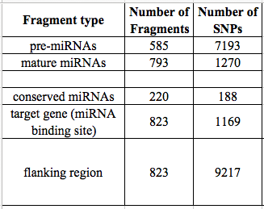

**Table 2.**

Target genes are only for conserved miRNAs. How did you identify the target genes? And the flanking regions are composed of miRNA binding site and its upstream and downstream ~100bp flanking regions.

(We obtain 823 target genes of 220 conserved miRNAs aided by online prediction tools and papers published.

After searching the 3K Rice SNP-Seek Database, we have found abundant SNPs in numerous types of genomic regions in question, including 7193 SNPs in pre-miRNAs, 1270 SNPs in mature miRNAs, 1169 SNPs in miRNA binding sites of the conserved miRNAs. In addition, we have searched SNPs for the ~100bp flanking regions of miRNA binding sites (include the binding sites), and the product is 9217 SNPs in total.)

1. **Basic info of combined haplotype patterns**

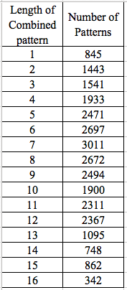

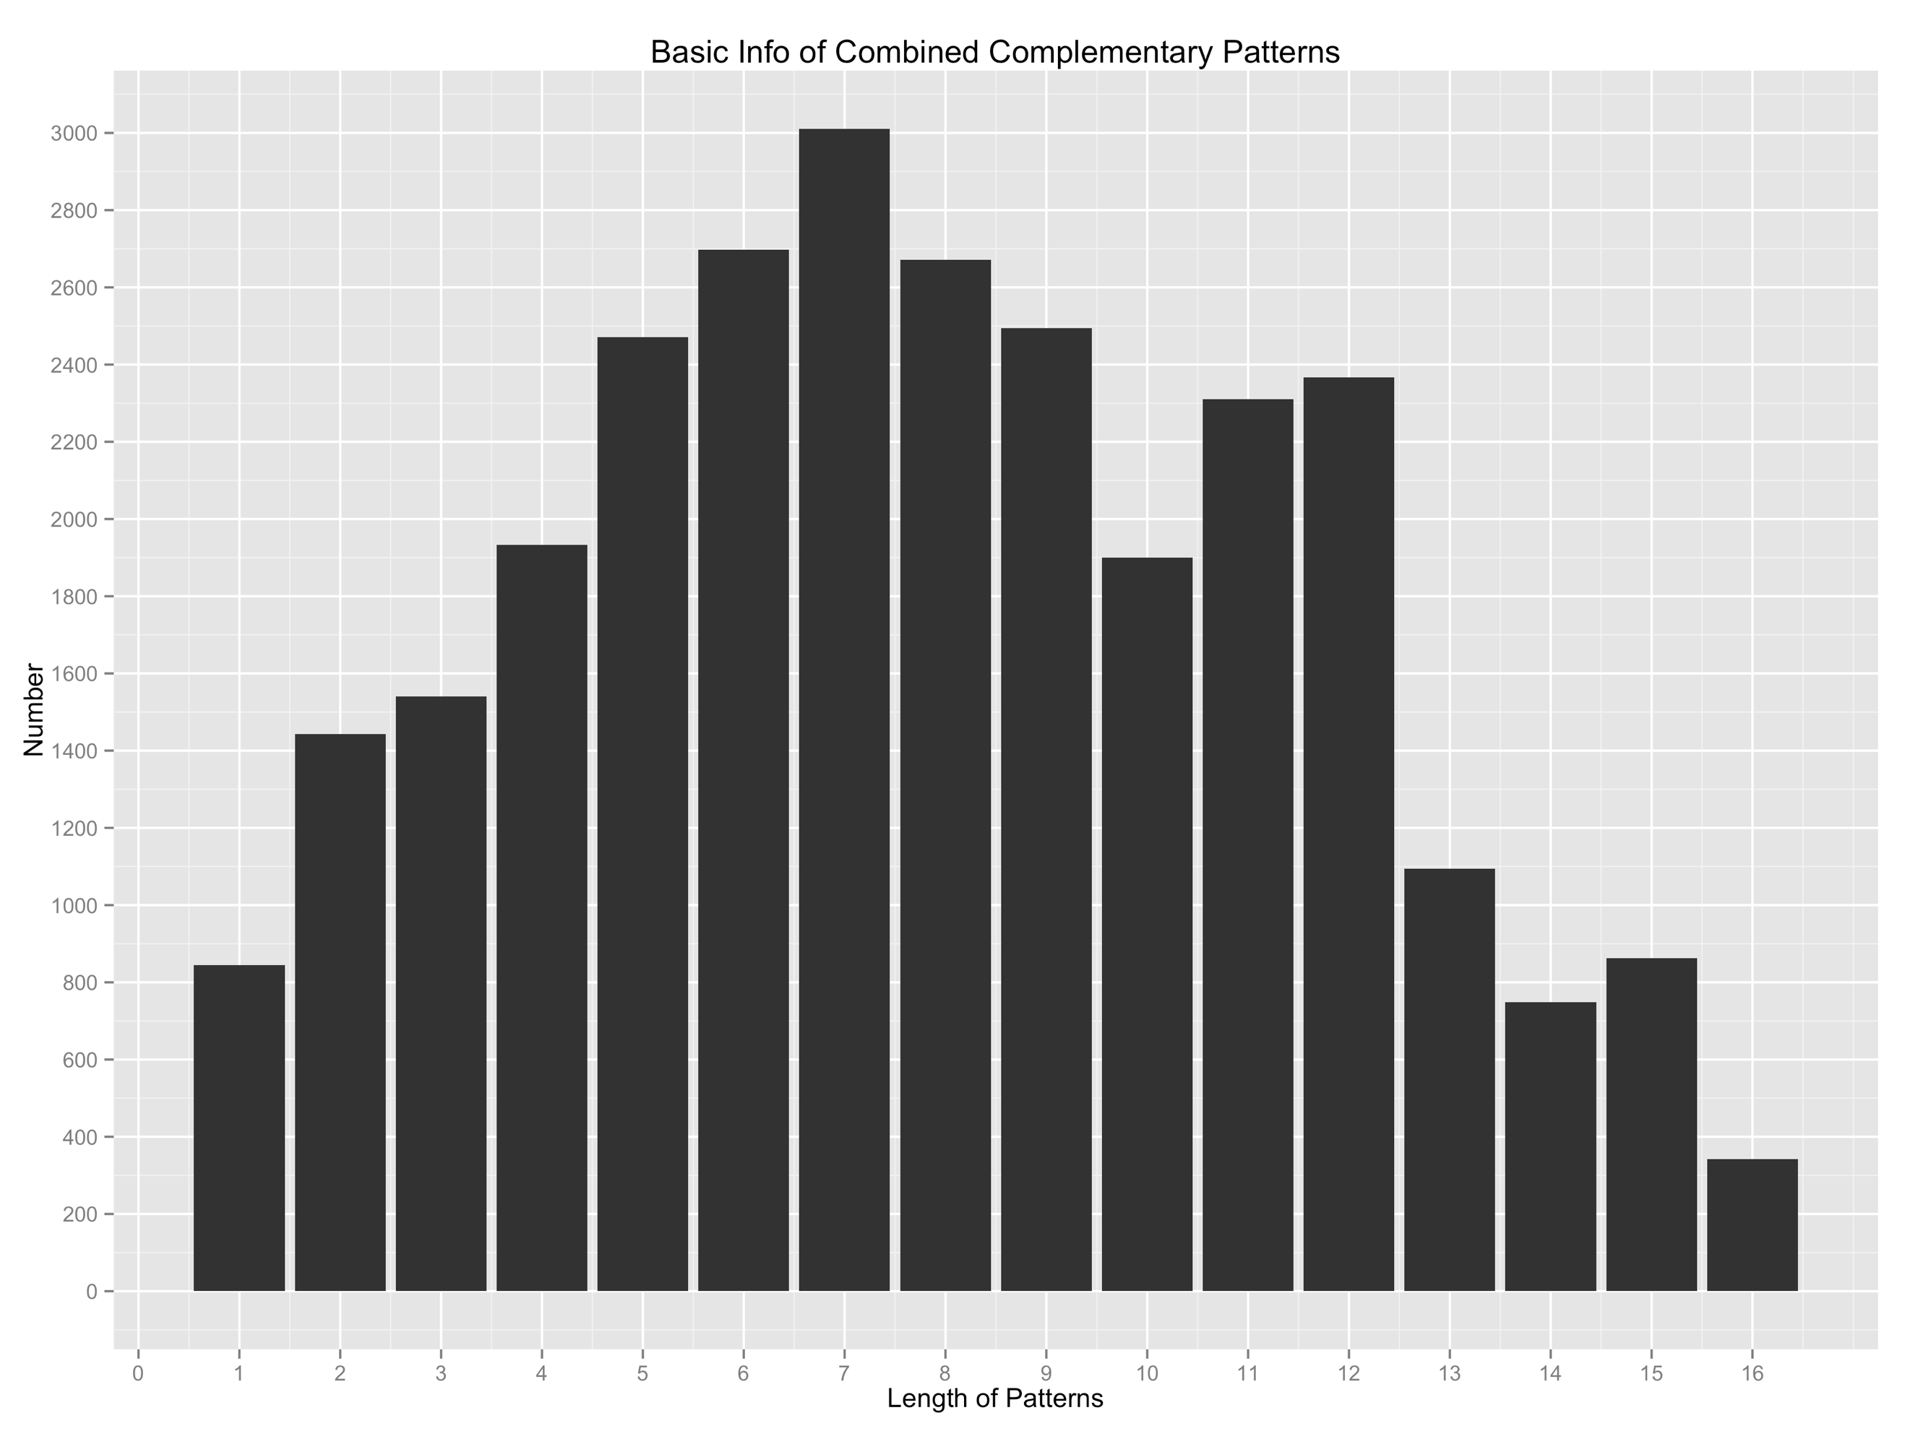

**Table 3**

Length of combined pattern stands for the length of patterns of combined haplotype, the number of SNPs of both mature miRNA and its binding site counterpart.

(We have analyzed 180 conserved miRNAs together with their 538 predicted target genes, and finally we obtained 28,732 unique combined haplotype patterns. And length of combined pattern stands for the length of patterns of combined haplotype, to wit, the number of SNPs of both mature miRNA and its binding site counterpart.)

1. **Basic statistical info of 4 categories of combined complementary patterns**

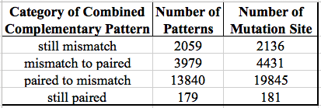

**Table 4.**

Second column is the number of combined complementary patterns that have site of the given category, and the third column is the total number of all sites that fall into the given category.

Still mismatch: after the point mutation(s), the state of complementarity of the site remains mismatched;

Mismatch to paired: after the point mutation(s), the state of complementarity of the site remains mismatched;

Paired to mismatch: the site turned mismatch after the point mutation(s);

Still paired: the state of complementarity remains paired.

**Part 2. Figures**

1. **SNP distribution figures**
   1. **Mature miRNA SNP distribution**

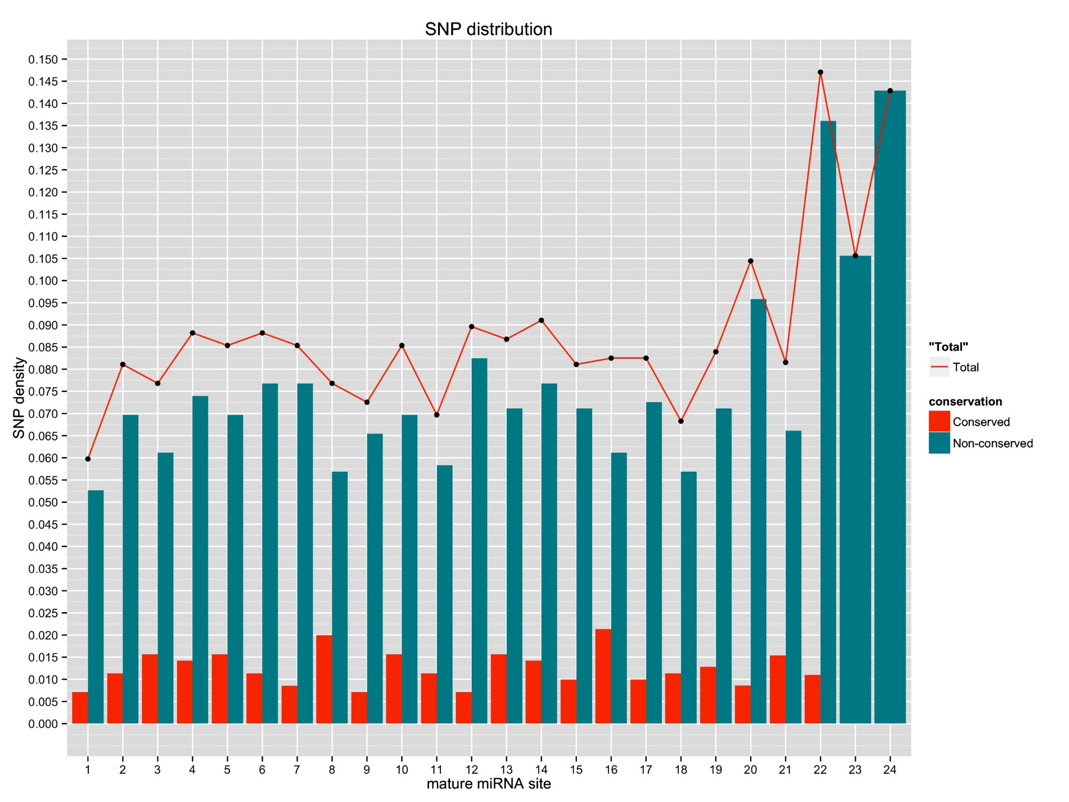

Figure 1. This is the SNP distribution?should it be frequency of mature miRNA.

SNP density = (Number of miRNAs possess SNP at the given site) / (Number of miRNAs have the given site);

;

The curve total stands for the SNP density distribution of all rice miRNAs included in this study. What is the trend??

* 1. **SNP distribution figure of miRNA binding sites in genes targeted by conserved miRNAs**

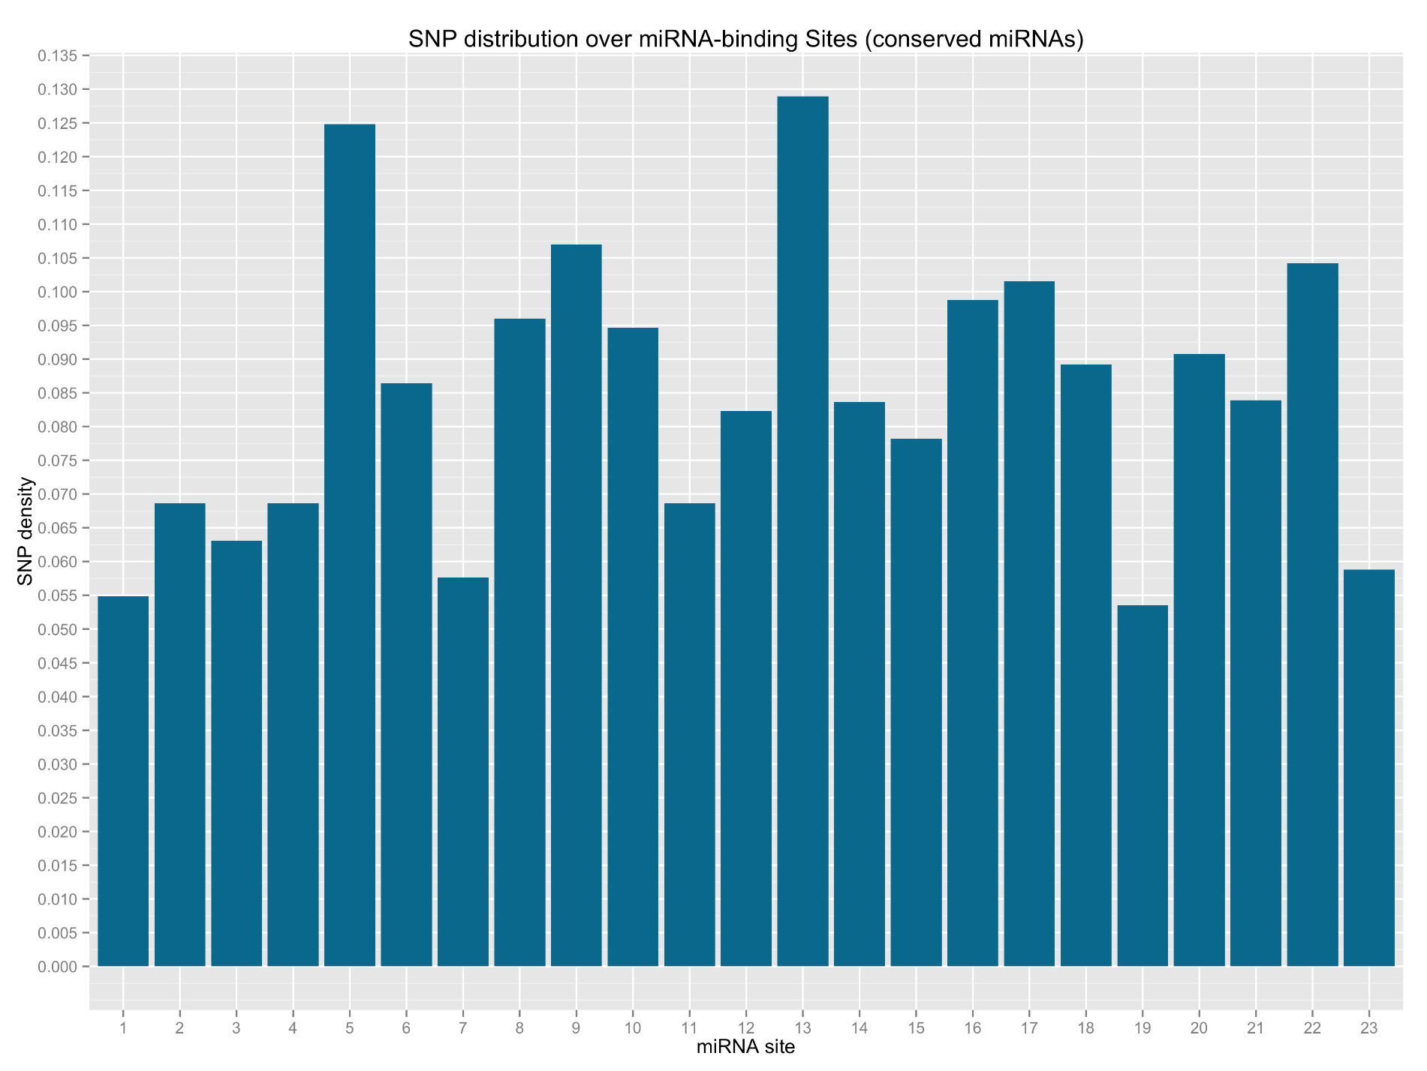

Figure 2a. miRNA site is by the same order as the 5’ - 3’ orientation in its mature miRNA counterpart.

* 1. **SNP distribution figure of miRNA binding sites in genes validated by degradome**

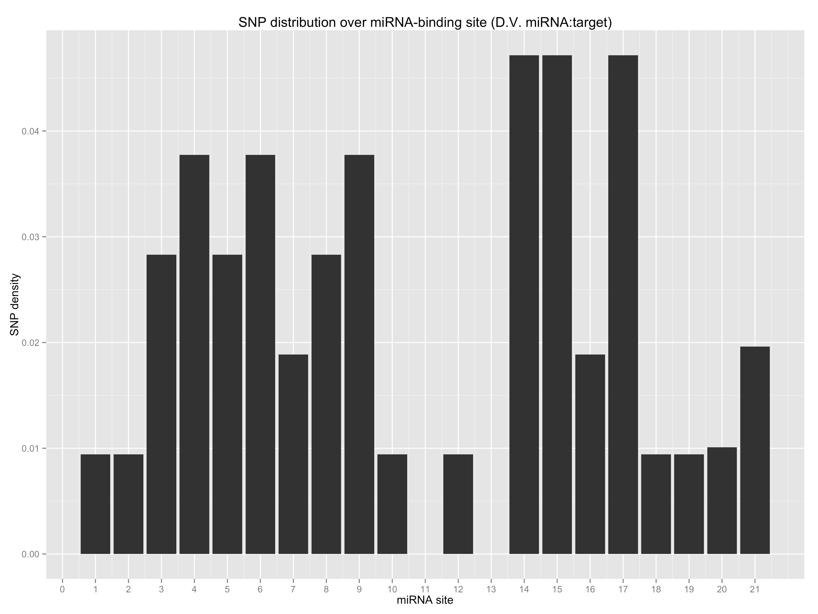

Figure 2b. (The same legend as Figure 2a)

1. **SNP density of pre-miRNAs**

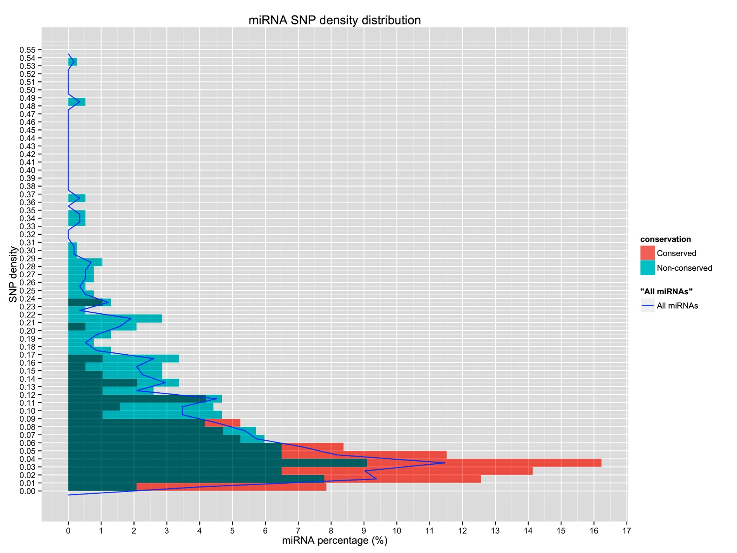

Figure 3. This is the figure of pre-miRNA SNP density distribution.

SNP density = (Number of SNPs found) / (miRNA length)

miRNA percentage = Number of miRNAs of the given SNP density / Number of miRNAs (of conserved / non-conserved / all)

Blue curve is the SNP density tendency of all miRNAs including conserved miRNAs and non-conserved miRNAs.

1. **SNP density comparison figures of pre-miRNAs with randomly chosen exons and intergenic regions**

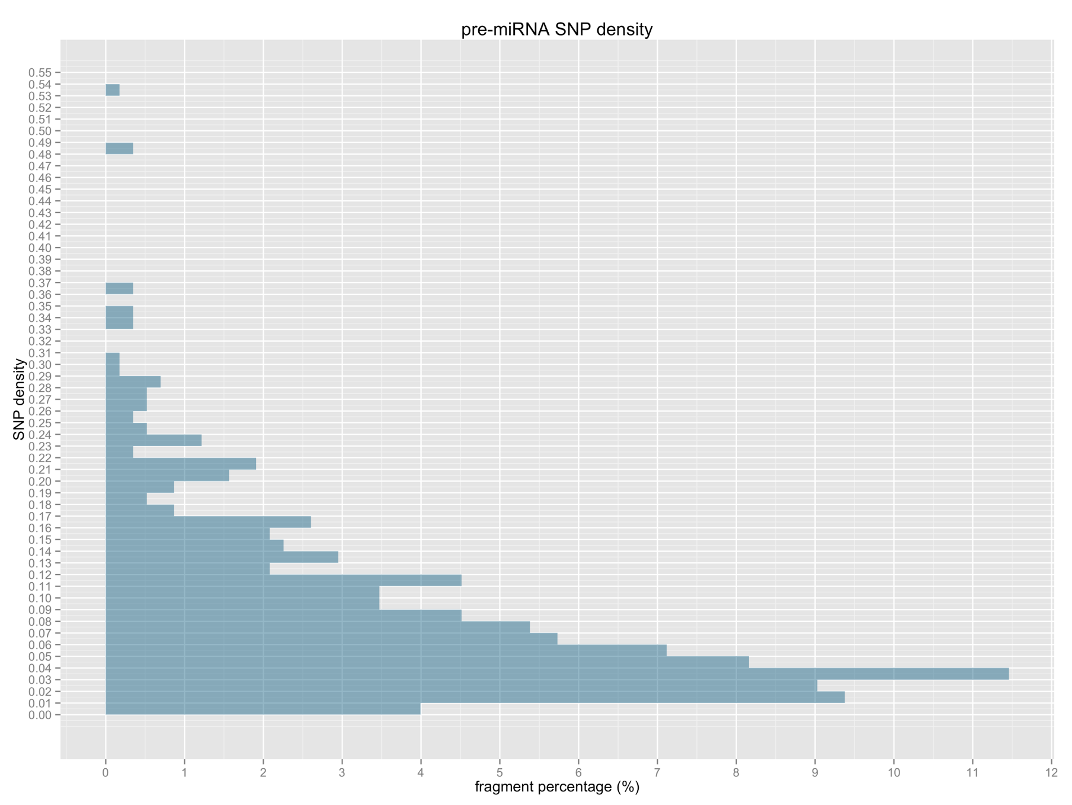

Figure 4a. SNP density of all pre-miRNAs

Fragment percentage = (Number of fragments with the given SNP density) / (Number of all fragments)

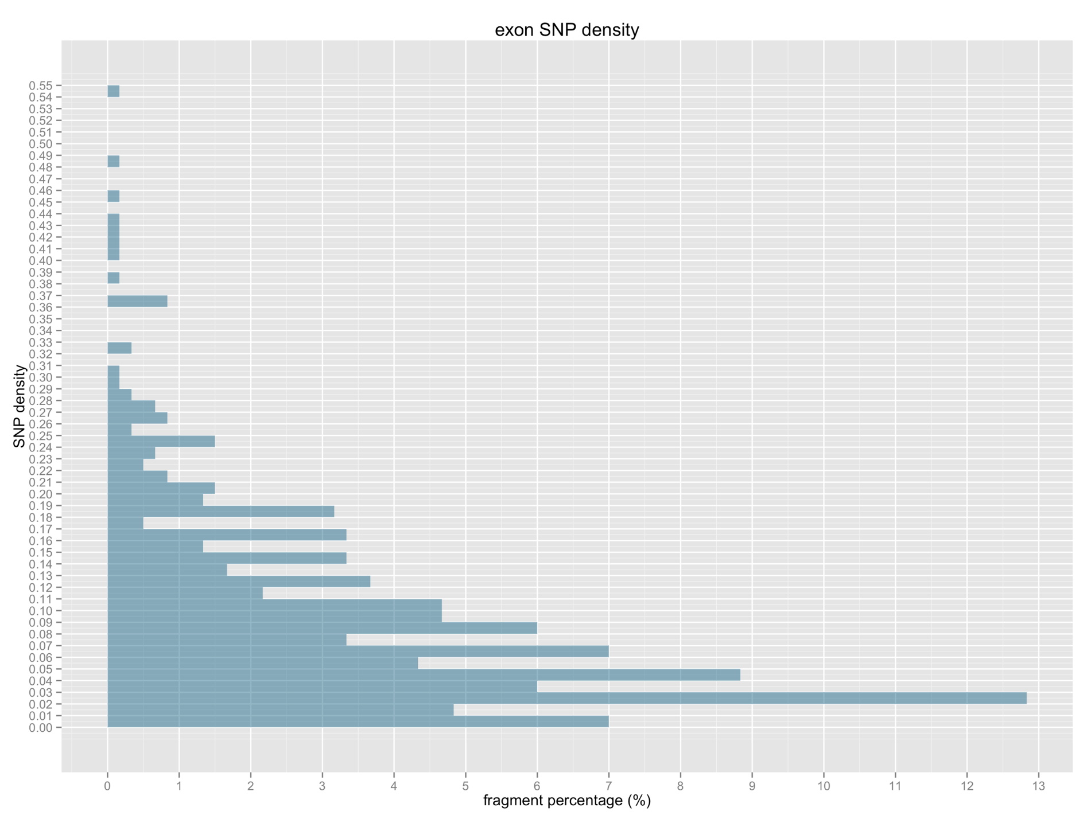

Figure 4b. SNP density of randomly chosen exon fragments.

50 fragments with the length of 150bp are randomly chosen from the exons in every of the 12 chromosomes.

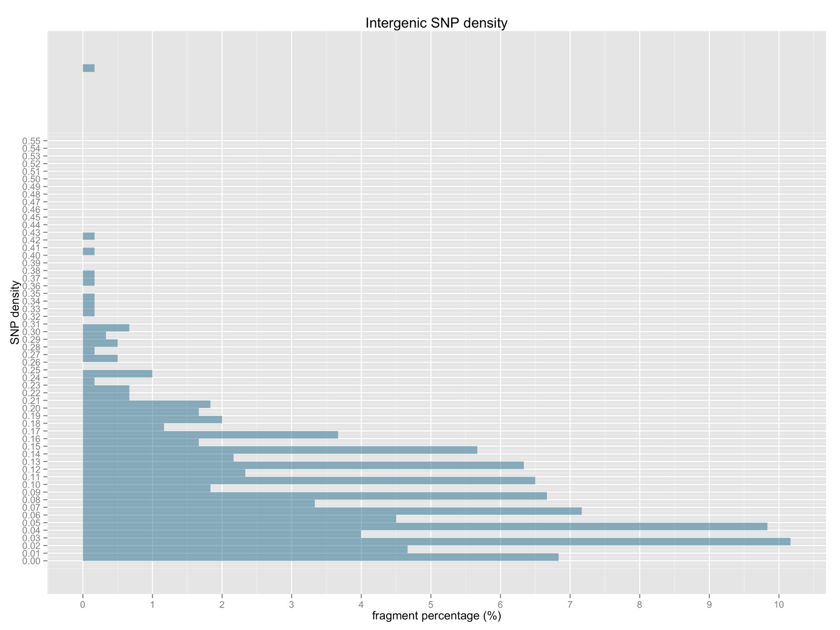

Figure 4c. SNP density of randomly chosen intergenic region’s fragments.

50 fragments with the length of 150bp are randomly chosen from the intergenic regions in every of the 12 chromosomes.

1. **Expression correlation of miRNA:target**
   1. **miR156 with OsSPL family correlation**

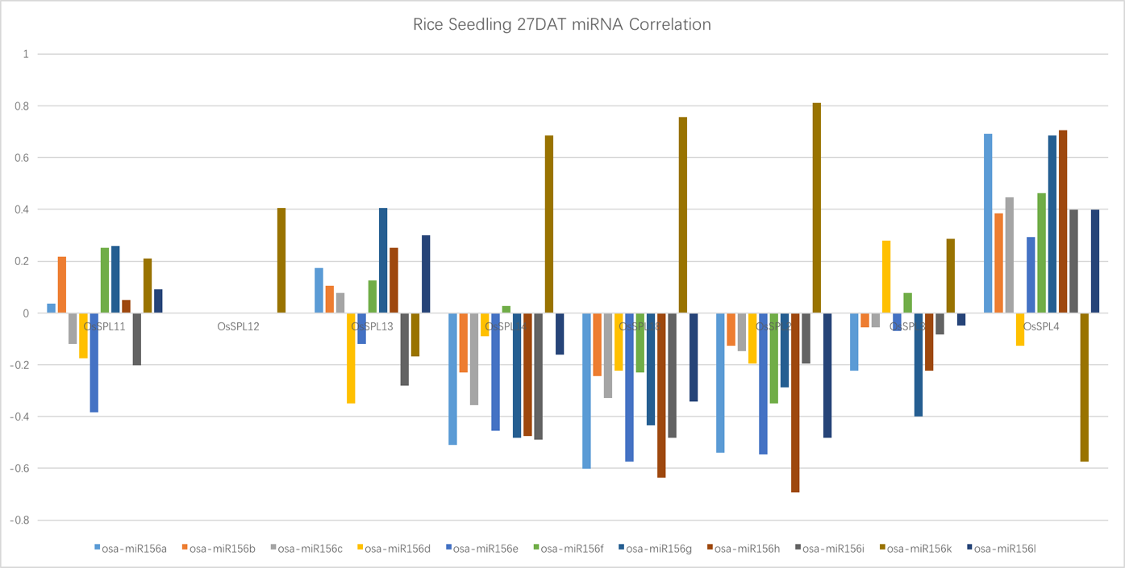

Figure 5a. This is the spearman correlation coefficient figure of expression of osa-pre?miR156 precursors and OsSPL family members, selecting samples of rice seedling at 27 Day After Transplanting, sample size = 12;

Positive value means the given miRNA is positively correlated with the gene in question, while negative value indicates the positive correlation???I don’t understand;

OsSPL12 is predicted to be targeted by osa-miR156k only, so its correlations with other miR156 members’ correlation values were not shown.

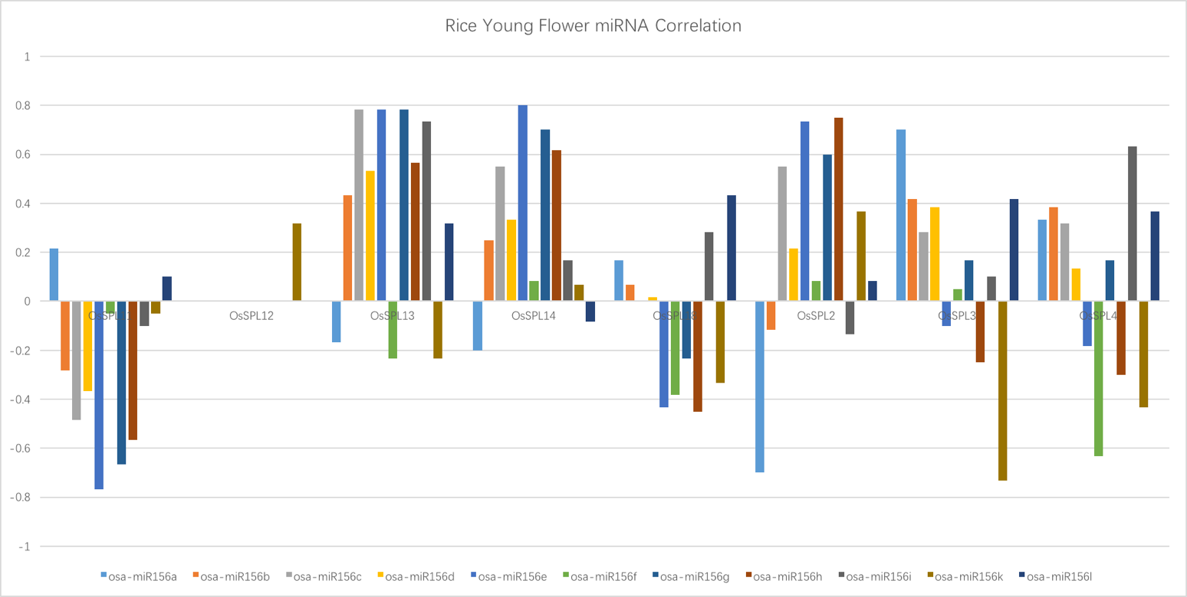

Figure 5b. This is the spearman correlation coefficient figure of expression of mature osa-miR156 and OsSPL family with samples of rice young flowers, sample size = 9.

* 1. **The tendency of expression correlation of degradome validated miRNA and target genes**

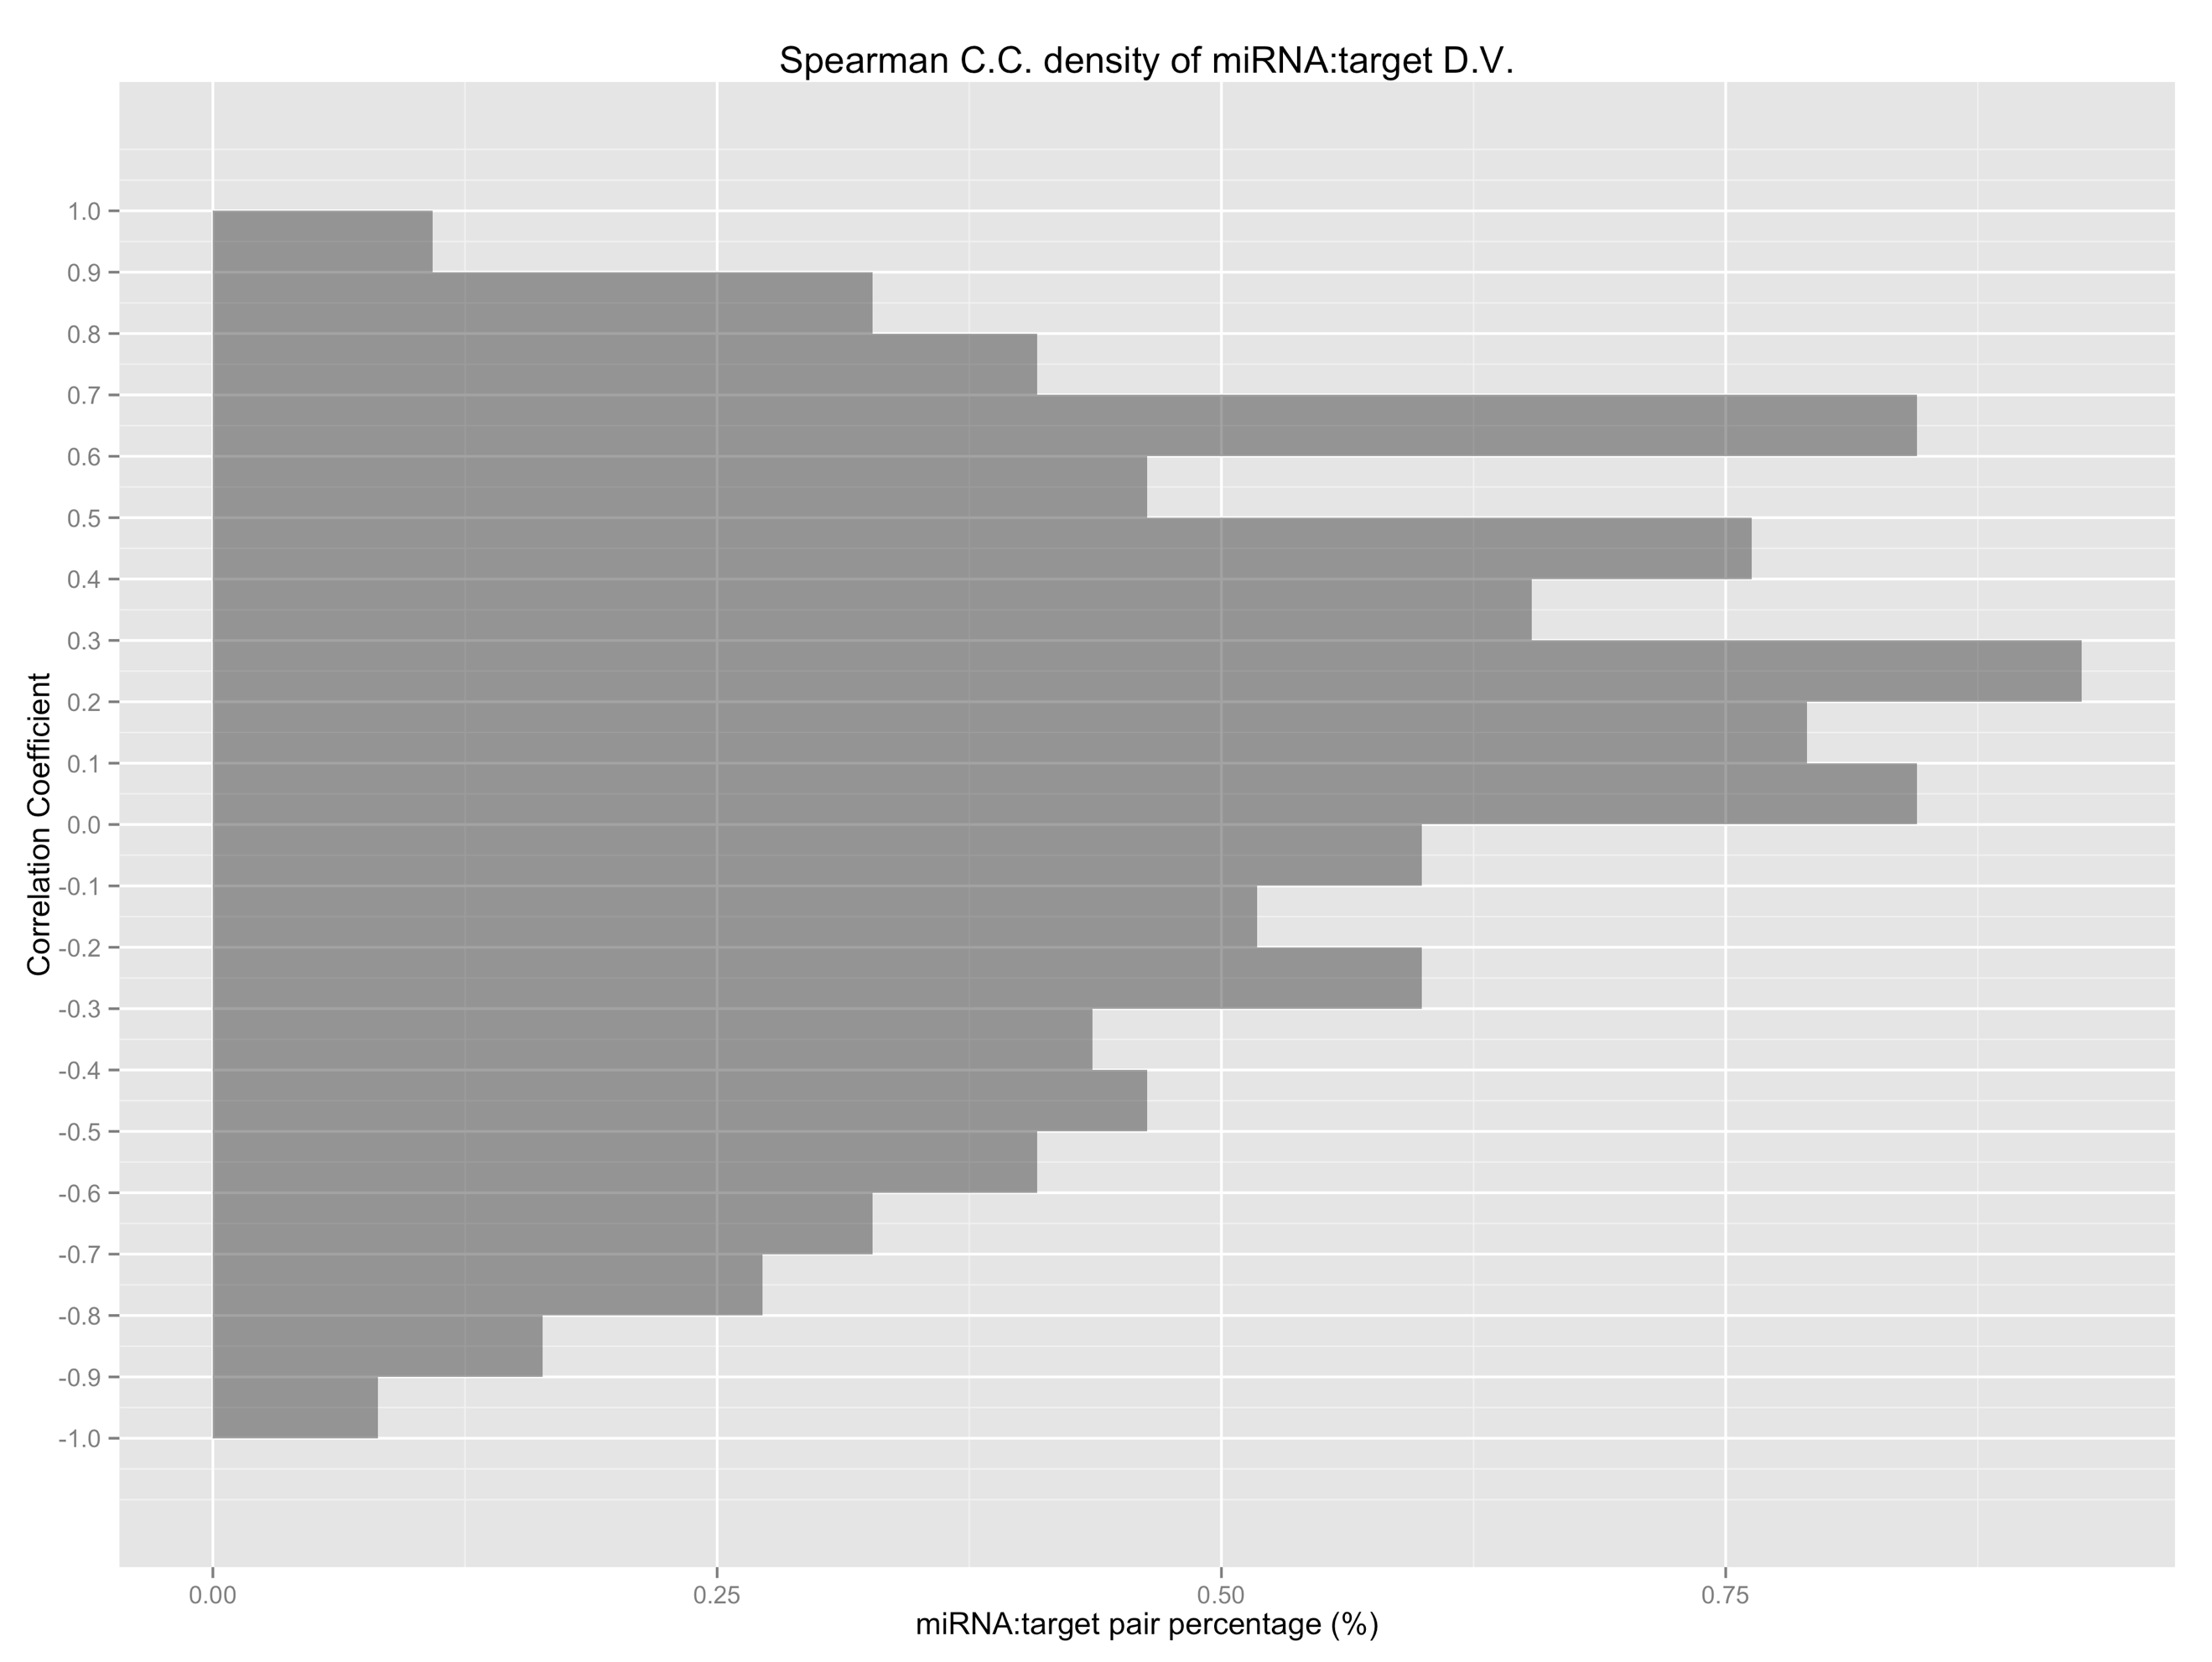

Figure 6. Histogram of spearman C.C (correlation coefficient) derived from the expression of selected mature? miRNAs and their degradome validated target genes. Samples are tissues from 27 DAT seeding, and sample size = 12.

miRNA:target pair percentage is the percentage of miRNA:target pairs that have spearman C.C. fall on the given C.C level.

What does the CC value mean?Where is the cut off if there is correlation?

1. **Illustrate 4 categories of combined complementary patterns**

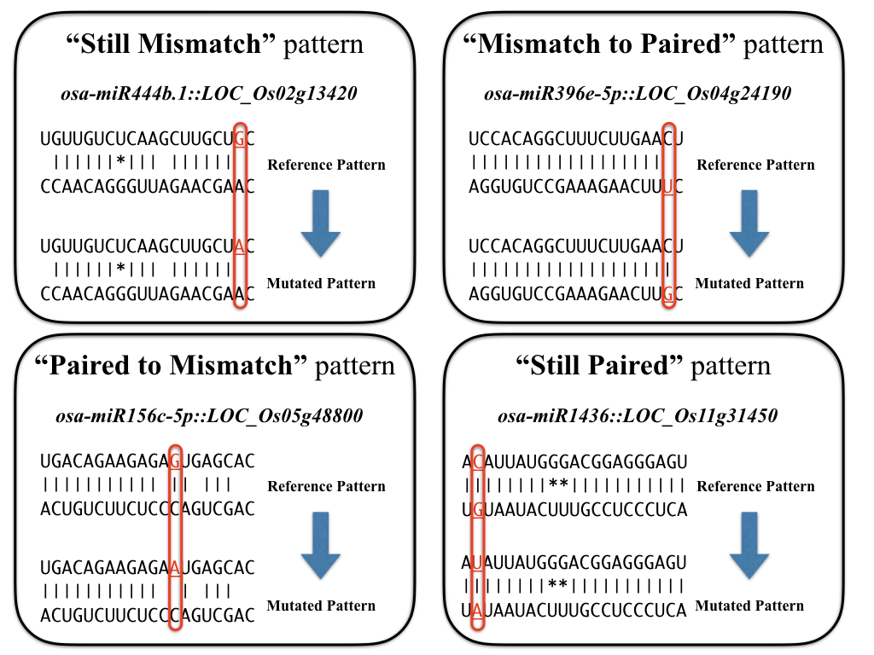

Figure 7. Four examples illustrate the 4 categories of combined complementary patterns.

1. **Methodology of combined complementary pattern analysis**

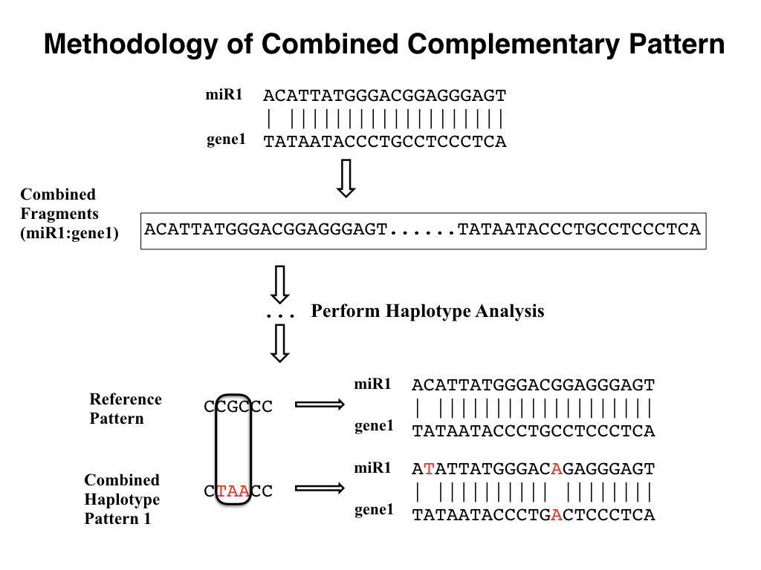

Figure 8. Methodology of how to do combined complementary pattern analysis

1. **Multifold combined complementary analysis illustrations**

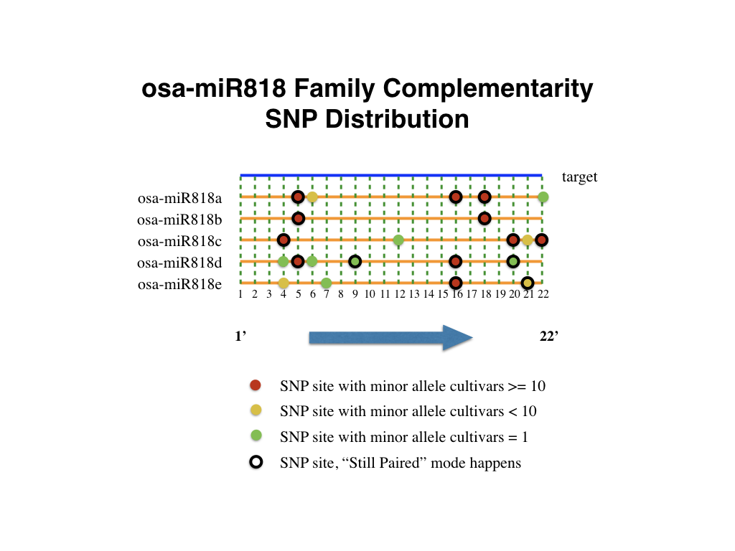

Figure 9. All osa-miR818 family members are aligned with their “assumed” target, every circle stands for a SNP found on that position with different colors showing the corresponding cultivar numbers.

1. **Haplotypes and phenotypes of corresponding cultivars**
   1. **Secondary Branching of osa-miR156 related haplotypes**

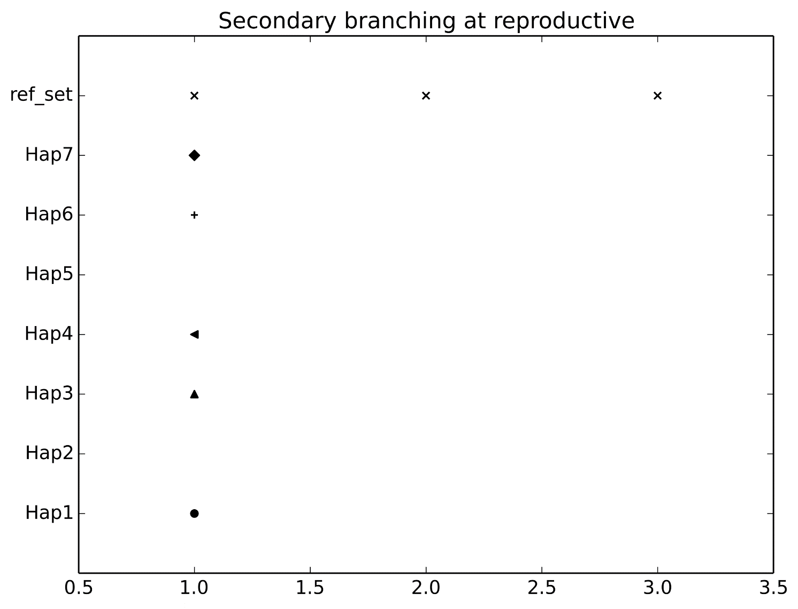

Figure 10. The secondary branching of cultivars of different haplotype patterns. Here 0 stands for absent, 1 stands for sparse (light), 2 stands for dense (heavy), 3 stands for clustering. Some haplotypes’ values are missing due to the lack of phenotype data of the corresponding cultivars.

* 1. Grain Size of osa-miR156 related haplotypes

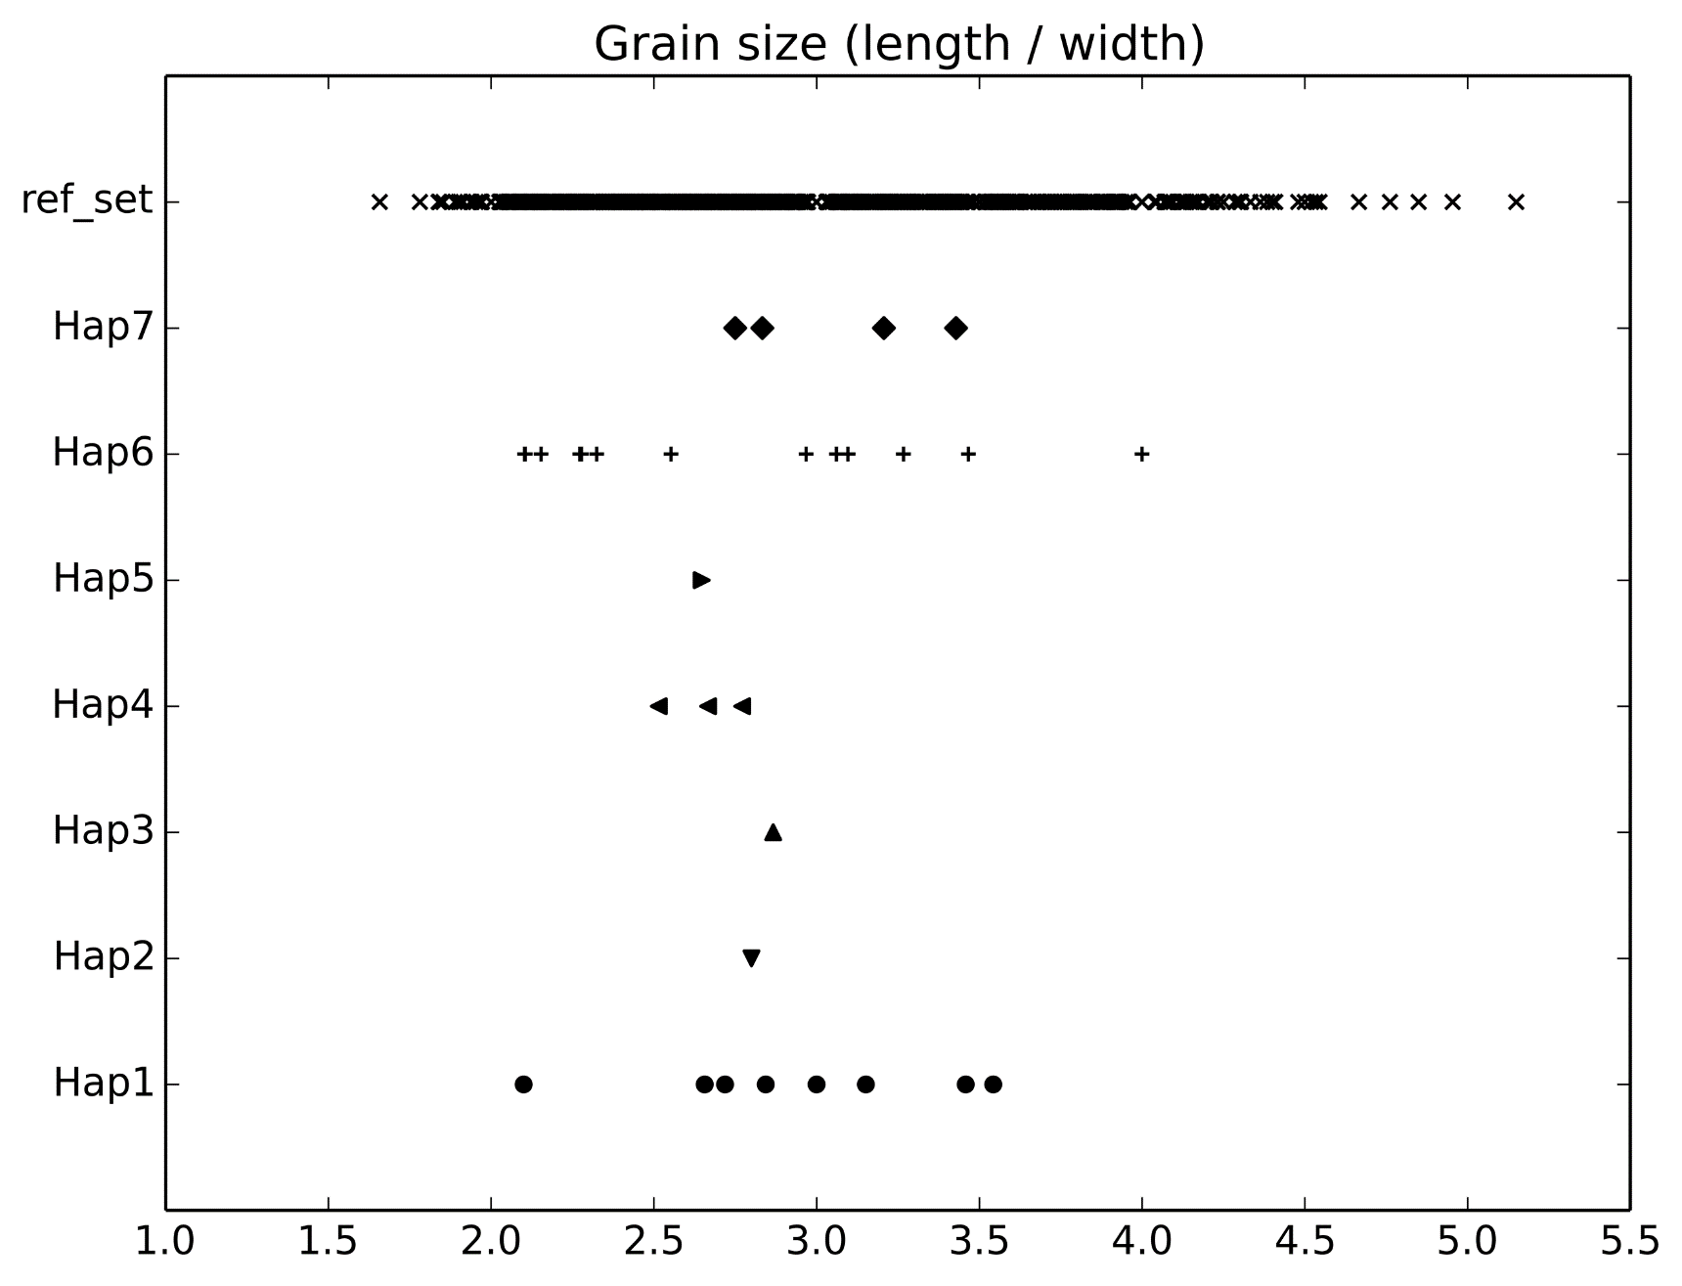

Figure 11. Grain size = Grain length / width.